JUST RUN® Graphic Standards
In Graphics:

- The standard design logo below is a symbol of the JUST RUN program. It should be used on apparel and in printed materials.



- Standard Character Mark, JUST RUN, is a registered trademark of the Big Sur Marathon Foundation.
- ® Symbol must be used immediately following JUST RUN Character Mark.
- The following is a suggested stylized design for printing JUST RUN.

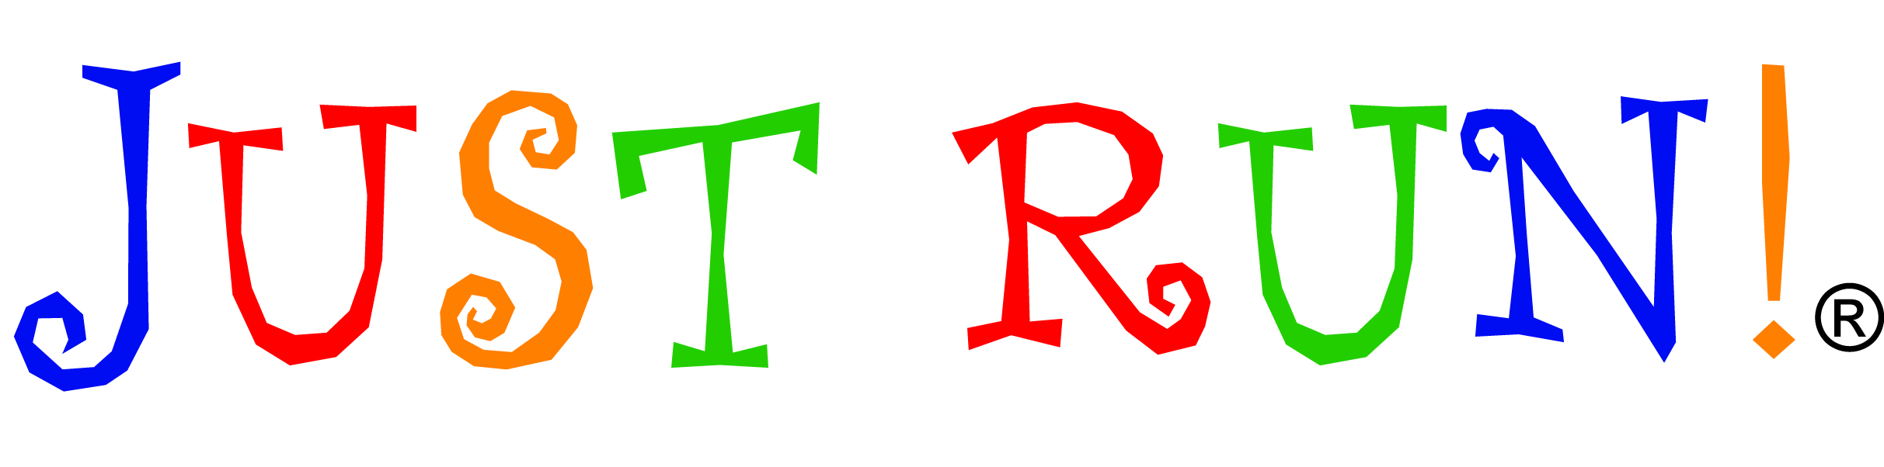

In Text:

- JUST RUN required in upper case letters.
- ® Symbol must be used immediately following JUST RUN® in first usage of name.
- For editorial usage (press releases, newsletters, body copy, etc.) JUST RUN may be used without the symbol within the document following first usage.

Big Sur Marathon Foundation Affiliation:

- Big Sur Marathon Foundation affiliation should be used in conjunction with JUST RUN wherever possible. Text to read:
  - A program of the Big Sur Marathon Foundation-or-
  - Official youth fitness program of the Big Sur Marathon Foundation
- Title of Big Sur Marathon Foundation may be either font of choice or registered BSMF logo.



